Test Data Specifications & Mock Records
Inside Hunters SFC Submission Document

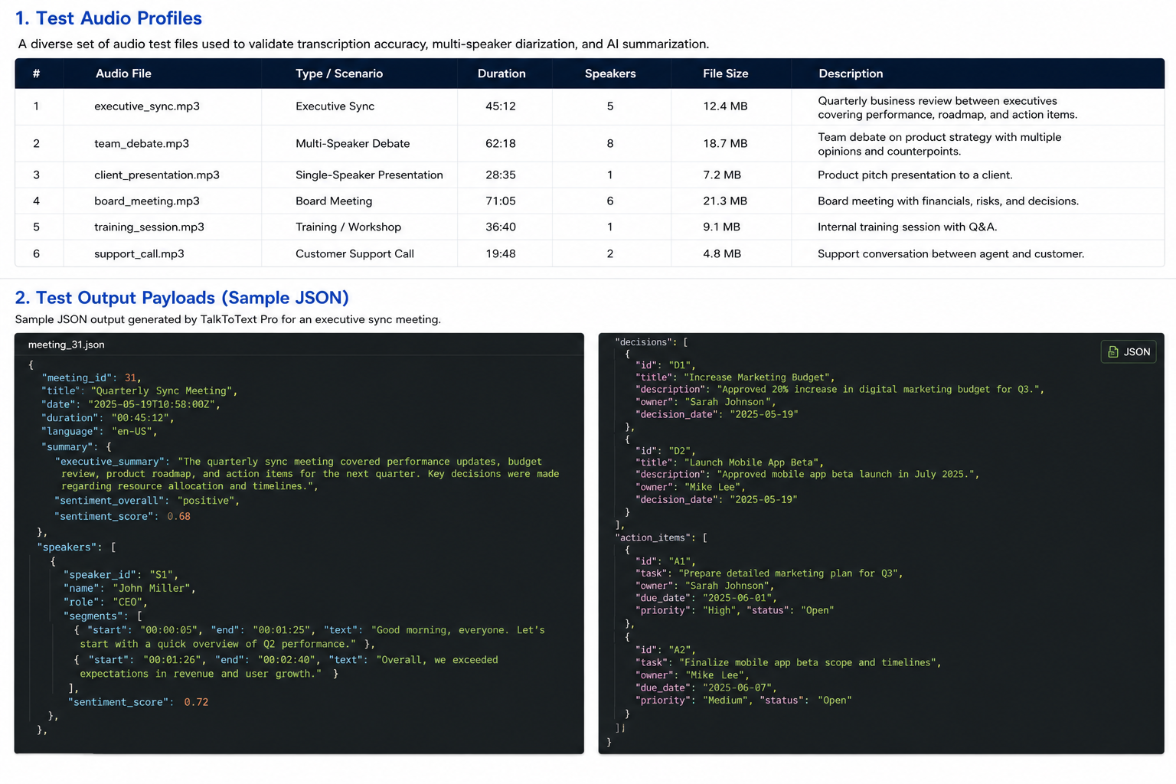

1. Test Audio Profiles
Includes executive sync recordings, multi-speaker debates, and single-speaker presentations.

2. Test Output Payloads
Sample JSON datasets with complete speaker transcripts, decisions, and action items provided in Test Data folder.

